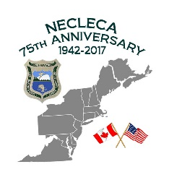
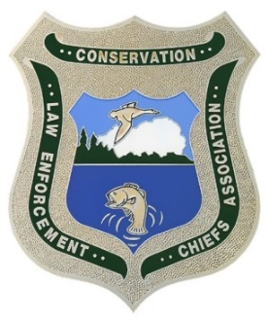
Northeast Conservation Law
Enforcement Chiefs Association

Join us for….. The 75th Anniversary of the
Northeast Conservation Law Enforcement Chiefs Association
2017 Fall Conference
Sunday October 1-Tuesday October 3, 2017

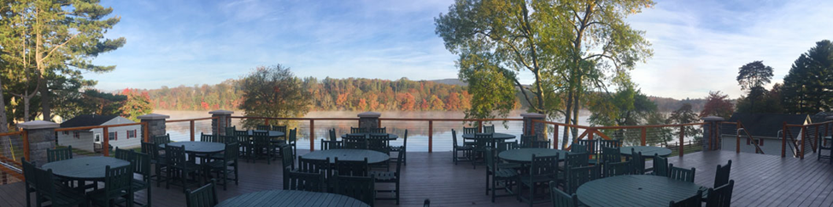
Trout Lake Retreats and conference center
Trout Lake, 1100 Twin Lake Road, Stroudsburg, PA 18360
(570) 620-0238
http://troutlakeretreats.com/

The fall 2017 Conference will be held at the Trout Lake Retreats and Conference Center. It is a 500 acre private facility conveniently located in the beautiful Pocono Mountains of northeastern Pennsylvania, only 10 minutes from Interstate 80. We have several heated lakeside cabins reserved and bunks with mattresses are available for all attendees. You will need to bring your own bedding. All meals, from the evening dinner on Sunday to breakfast on Tuesday, will be provided. Due to PA Liquor License laws and regulations, no outside alcoholic beverages are permitted on the premises, however, there will be an open bar offered from 4pm until midnight on Sunday and Monday. License free fishing will be offered one day during the conference as organized by the Pennsylvania Fish and Boat Commission and rowboat and paddleboats will be available. Outside covered table games and volleyball, fire pits with S’mores and lakeside views are part of the package as well.

We will be celebrating the 75th Anniversary of our organization that was established in Harrisburg Pennsylvania in 1942. We are grateful to the NECLECA. The cost of this event is being subsidized by our organization so that we can supply you with an outstanding experience in Pennsylvania and give each attendee a few items with the 75th Anniversary logo.

Northeast Conservation Law
Enforcement Chiefs Association

Itinerary of Events and Training

Sunday October 1, 2017
1300- Check in opens
1600-2200 Social/Networking Opportunity
1700-1800 Dinner at the Boathouse
2000-2100 Campfire and S’mores

Monday October 2, 2017
0800-0900 Breakfast at Main Dining Hall
0900-1100 NECLECA Fall Meeting
1100-1200 Training-PGC Lessons Learned: Going Paperless in the World of Conservation LE
1200-1300 Lunch at the Main Dining Hall
1300-1400 Training-Body Cameras in Conservation Law Enforcement
1400-1500 Training-IHEA HRSI Investigation Academy Overview
1500-1600 NECLECA State Reports
1600-2200 Social/Networking Opportunity
1700-1800 Dinner at the Main Dining Hall
2000-2100 Campfire and S’mores

Tuesday October 3, 2017
0800-0900 Breakfast and the Main Dining Hall
0900-1200 NECLECA Fall Meeting Conclusion
1200 Check out

2017 NECLECA FALL CONFERENCE REGISTRATION
Cost of Registration $200.00 per Attendee
Agency:

Attendee Information:
Name:
Address:
Contact Phone No.: |  | T-Shirt Size: | S M L XL XXL
Name:
Address:
Contact Phone No.: |  | T-Shirt Size: | S M L XL XXL
Name:
Address:
Contact Phone No.: |  | T-Shirt Size: | S M L XL XXL
Name:
Address:
Contact Phone No.: |  | T-Shirt Size: | S M L XL XXL
Name:
Address:
Contact Phone No.: |  | T-Shirt Size: | S M L XL XXL
Name:
Address:
Contact Phone No.: |  | T-Shirt Size: | S M L XL XXL

Please make checks payable to: Northeast Conservation Law Enforcement Chiefs Association (NECLECA)
Registrations and payments must be received no later than September 1, 2017. Please mail to:

Pennsylvania Game Commission
Bureau of Wildlife Protection
Attn: Chad Eyler
2001 Elmerton Ave.
Harrisburg, PA 17110

