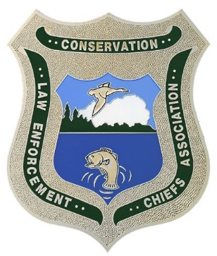
RHODE ISLAND MAINE
PRINCE EDWARD ISLAND MASSACHUSETTS
NEW YORK
NEW HAMPSHIRE
ONTARIO MARYLAND
VERMONT
NEW JERSEY NOVA SCOTIA DELAWARE
NEW BRUNSWICK PENNSYLVANIA QUEBEC CONNECTICUT VIRGINIA

Northeast Conservation Law Enforcement Chiefs Association
REGION 5 US FISH & WILDLIFE SERVICE • NATIONAL MARINE FISHERIES SERVICE, NORTH EAST REGION • ROYAL CANADIAN MOUNTED POLICE

2019 Fall Workshop

Meeting Notice

Our fall workshop has been scheduled for September 29 through October 1, 2019 and will be held at the Eisenhower House on the grounds of Fort Adams State Park in Newport, Rhode Island. NECLECA registration fee will be $250.00 and we have secured a block of rooms at the Newport Harbor Hotel and Marina at 49 America’s Cup Avenue in downtown Newport along the waterfront. The room rate is $199.00 plus a $35.00 fee for parking and other amenities, and taxes. To make your reservation please contact the hotel at 401-847-9000. The block of rooms is under NECLECA. We will still be in season for Newport with many local activities for all to participate in as desired.

NECLECA FALL WORKSHOP REGISTRATION

Cost of Registration $250.00 per Attendee

Attending Agency: ______________________________________________________________________

Agency Members Attending: _____________________________________________________________

Address & Contact Info: _________________________________________________________________

_________________________________________________________________

__________________________________________________________________

__________________________________________________________________

__________________________________________________________________

Please make check payable to: Northeast Conservation Law Enforcement Chiefs Association
(NECLECA)

Please return registration no later than September 15, 2019 to: Deputy Chief Kurt Blanchard
RIDEM / Environmental Police
235 Promenade Street, Suite 250
Providence, RI 02908

