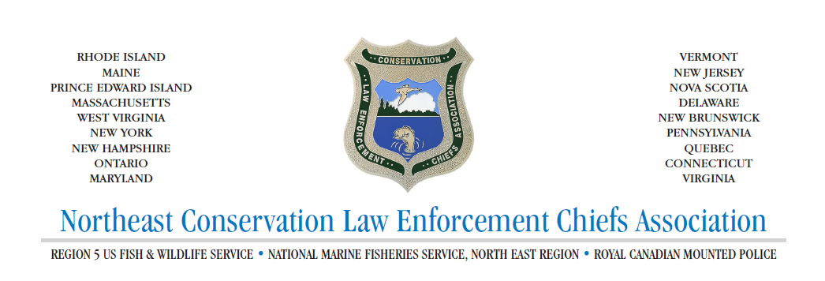

Agenda and Roster Fall Chief’s Meeting 2022
October 2, 3, 4 2022

Sunday - 3:00- 6:00 p.m. Arrival and dinner.
Monday- 8:00 Breakfast in Dining Hall

- 8:00 a.m. Scheduled Training and Activities
- 12:00 p.m. Lunch
- 1:00 p.m. Scheduled Training
- 5:00 p.m. Dinner in Dining Hall
- 6:30 p.m. Case Presentation – CT Black Bear Incident Newtown

Tuesday- 8:00 Breakfast in Dining Hall

- 9:00 a.m. NECLECA Business Meeting – Agenda to Follow
- 11:00 a.m. Brunch and depart.

