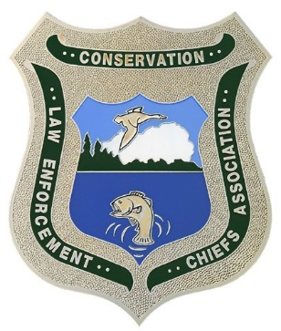
RHODE ISLAND MAINE
PRINCE EDWARD ISLAND MASSACHUSETTS
NEW YORK
NEW HAMPSHIRE
ONTARIO MARYLAND
VERMONT
NEW JERSEY NOVA SCOTIA DELAWARE
NEW BRUNSWICK PENNSYLVANIA QUEBEC CONNECTICUT VIRGINIA

Northeast Conservation Law Enforcement Chiefs Association
REGION 5 US FISH & WILDLIFE SERVICE • NATIONAL MARINE FISHERIES SERVICE, NORTH EAST REGION • ROYAL CANADIAN MOUNTED POLICE

2022 Fall Workshop

Meeting Notice

Our fall workshop has been scheduled for September October 2nd through 4th, 2022 and will be held at White Memorial Conservation Center Litchfield, Connecticut. NECLECA registration fee will be $300.00 per person.
80 WHITEHALL ROAD
P.O. BOX 368
LITCHFIELD, CT 06759

NECLECA FALL WORKSHOP REGISTRATION

Cost of Registration $300.00 per Attendee

Attending Agency:
Payment for the following Agency Members Attending:

Please make check payable to: Northeast Conservation Law Enforcement Chiefs Association
(NECLECA)

Please return registration payment no later than September 15, 2022, to: Michael Reeder
PA Game Commission
2001 Elmerton Ave.
Harrisburg, PA 17110

