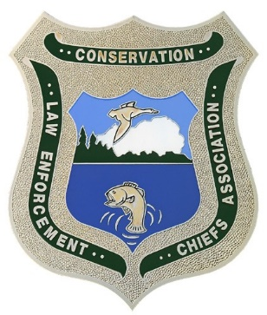
RHODE ISLAND MAINE
PRINCE EDWARD ISLAND MASSACHUSETTS
NEW YORK
NEW HAMPSHIRE
ONTARIO MARYLAND
VERMONT
NEW JERSEY NOVA SCOTIA DELAWARE
NEW BRUNSWICK PENNSYLVANIA QUEBEC CONNECTICUT VIRGINIA

Northeast Conservation Law Enforcement Chiefs Association
REGION 5 US FISH & WILDLIFE SERVICE • NATIONAL MARINE FISHERIES SERVICE, NORTHEAST REGION • ROYAL CANADIAN MOUNTED POLICE

2026 Fall NECLECA Meeting Agenda –

Tuesday September 29
Travel & Arrival to Pittsburg
5 PM Welcome
Dinner – BBQ – Networking in the evening - Hospitality around the fire.
Anyone arriving early can do some sightseeing, go fishing in the area or take a cruise on a boat/pontoon boat.

Wednesday September 30
Presentation by Eversource in the morning. Eversource is a conference sponsor and will be providing breakfasts for our conference.
Free time early morning until early evening.
There will be an information session on trolling and fly-fishing on where to go and what to use. Fly-fishing opportunities on rivers and streams to include: the Connecticut River or lake trout/salmon fishing on the Connecticut Lakes (fishing license required).
For those who do not want to fish, I will set up an off-road UTV trip (attendees will need to rent UTV’s from Bear Rock Rentals).
Dinner at the Cabins – Pasta Night – Chicken Parm, Caesar Salad, Garlic Bread and Desert.
Hospitality around the fire. Hospitality Night sponsored by Dana Safety Supply / Federal Signal.

Thursday October 1
Breakfast in the morning.
Bagged Lunch in the afternoon.
Opening day of small game and upland bird. The plan will be to break up into small groups and hunt the Pittsburg area (hunting license required). Pittsburg also has a pheasant cover where birds are stocked (a pheasant stamp and hunting license would be required).
For those who do not want to hunt, fly-fishing opportunities on rivers and streams to include: the Connecticut River or spin fishing around trout ponds – (fishing license required – Lake Trout/Salmon areas are closed).
Dinner – Surf & Turf -Prime Rib, Shrimp, Roasted Red Potatoes, Salad, Vegetables and Desert.
Business Meeting in the evening.
Hospitality around the fire.

Friday October 2
Breakfast in the morning
Additional hunting opportunities in the area or fishing opportunities in rivers, streams and trout ponds (Lake Trout/Salmon waters are closed).
Departure – Check Out in early afternoon.

