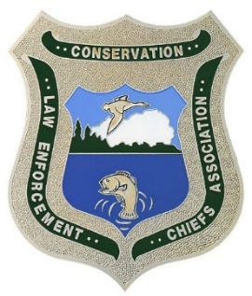

RHODE ISLAND MAINE
PRINCE EDWARD ISLAND MASSACHUSETTS
NEW YORK
NEW HAMPSHIRE
ONTARIO MARYLAND
VERMONT
NEW JERSEY NOVA SCOTIA DELAWARE
NEW BRUNSWICK PENNSYLVANIA QUEBEC CONNECTICUT VIRGINIA
WEST VIRGINIA

Northeast Conservation Law Enforcement Chiefs Association
REGION 5 US FISH & WILDLIFE SERVICE • NATIONAL MARINE FISHERIES SERVICE, NORTHEAST REGION • ROYAL CANADIAN MOUNTED POLICE

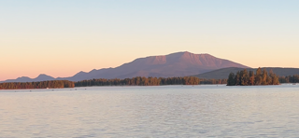
2026 Fall Meeting Pittsburg, New Hampshire 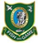
Good afternoon, everyone,

I hope you are all doing well and surviving the summer season. The 2026 Fall NECLECA meeting will be held at Bear Tree – Glen Lodge in Pittsburg, New Hampshire on First Connecticut Lake from September 29, 2026 – October 2, 2026 hosted in conjunction with the New Hampshire Fish & Game Conservation Officers (www.atbeartree.com). This is a beautiful venue and one I think will be well worth attending, especially during the fall foliage season! Specifically, we will be staying at the Glen on First Connecticut Lake. There are overflow cabins away from the water that bring the total sleeping accommodations to 42. New Hampshire Fish & Game also have their Warden’s camp on First Connecticut Lake where some people can sleep as well bringing the total accommodations to 50 for the conference.

Attached is the tentative agenda arriving at 5:00 PM on Tuesday September 29th and departing on Friday October 2nd. The cost per person is $500.84 for active members and $250.42 for retirees (NECLECA will pay the other half). This includes three nights’ lodging, breakfast every morning, bagged lunches in the afternoon and some nice dinners each evening.

Please call Chantal Carney, Director of Sales & Marketing at Bear Tree (603-538-9995) to register no later than August 21, 2026. Tell her you are with the Northeast Conservation Law Enforcement Chiefs Association (NECLECA). If you are a retiree, please advise Chantal when you call to be charged the reduced rate. Also, please email myself keith.williams@ct.gov and Rob Mancini robert.m.mancinijr@wildlife.nh.gov to let us know how many are coming from each state. Retirees, please do the same so we know how many of you are coming as well.

It is an approximate 3-hour drive from Burlington International Airport to Pittsburg, NH and approximately 3 hours and 14 minutes from Manchester, NH International Airport to Pittsburg, NH. It is highly recommended to rent a vehicle from there as there will be opportunities for travel and sightseeing along with hunting and fishing opportunities (with license purchase) in the area of the Bear Tree – Glen Lodge. Upland bird season starts on October 1, 2026.
***Please note the cost noted above does not include a hunting/fishing license or UTV rental (LT Mancini is working on a special rate for the UTV rentals).
If you have any questions or concerns, please feel free to reach out to me.

Respectfully,

Keith Williams
keith.williams@ct.gov 860-461-8061

Things to consider:
There will be some kayaks available for those that want to take a paddle, some fishing gear available and can provide a few shotguns. Ideally, the people fly-fishing and hunting will have the gear they need, but we will try to accommodate attendees—especially those that are flying.
Canada is a short trip away for those that bring their passports.
The current cost of a non-resident 3-day small game license is $25.00, and a non-resident 3-day fishing license is $28.00.
Anyone that wants to extend their stay in Pittsburg can contact the lodge directly. I am not sure what the rates would be, but if it was booked early enough, I am told people could stay through the weekend of October 4th.
The weather can be on the cool side during this time frame, especially in the mornings and evenings. A rain jacket / light jacket with some optional layers would be recommended.

